**IST 263 Project Milestone 6 – First Draft Using CSS**

**Name**: Iseabail Kelley

**Description:**  
For my project, I want to create an educational platform where I can write, speak, and create art about certain topics I am passionate about. This site will be a blog, as opposed to a traditional portfolio, where I can create my own content instead of simply displaying content I’ve already made (as I would do in my portfolio). As a magazine journalism dual major, I love to spread awareness about topics I am interested in, whether it be the economy and finance, the environment and sustainability, or art/fashion and 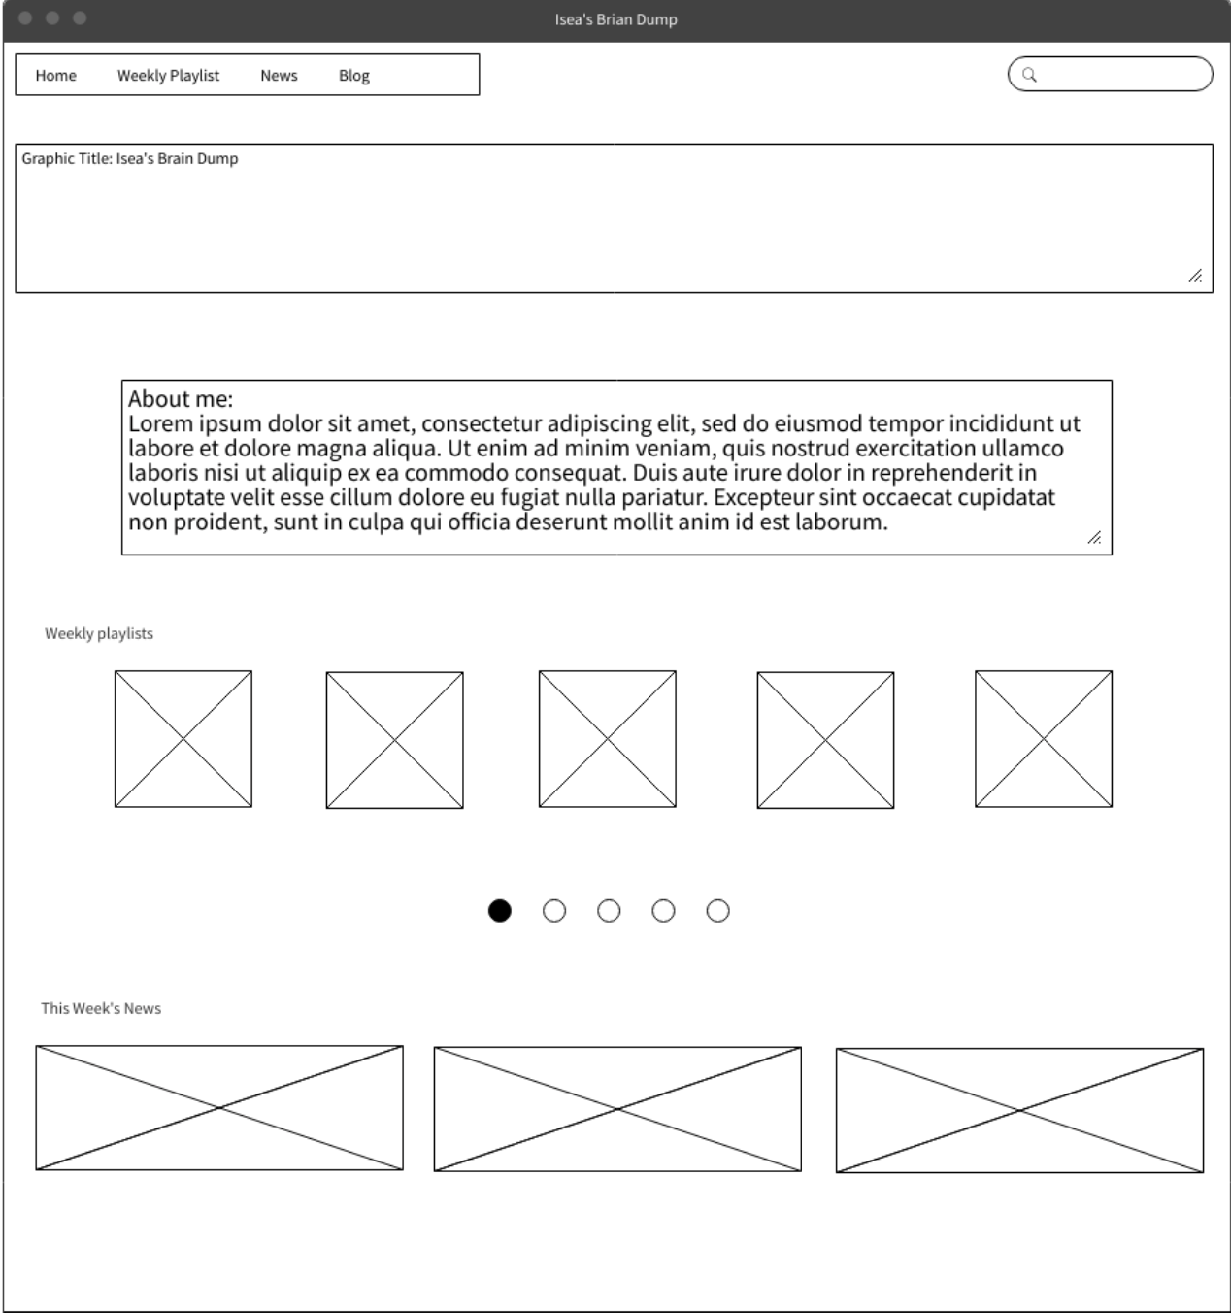music. I would like to split up my website logically, having three different sections depending on the type of media I use. For example, I would have a section for my blog, one section on recommended music, and another section sharing/critiquing news, especially in fashion trends/art/music. Although a lot of work, I am willing to put in the effort for this site and create a platform that represents my interests while also informing and entertaining others.

**What is the url of the page you choose to work on for this part?**

<https://iseakelley52.github.io/ist263/project/skeletonsite/skeleton.html>

**Paste a screen shot of the wireframe you created for this page below.**

**Provide the URL of the WAVE checker for this page below.**

<https://wave.webaim.org/report#/https://iseakelley52.github.io/ist263/project/skeletonsite/skeleton.html>

**Provide the URL of the HTML validator for you page below.**

<https://html5.validator.nu/?doc=https%3A%2F%2Fiseakelley52.github.io%2Fist263%2Fproject%2Fskeletonsite%2Fskeleton.html>

**If something went wrong in this part, describe what happened and how you can fix it moving forward.   
Examples of problems could be, page isn’t responsive, page doesn’t look like wireframe, etc.**

**After working on my site more, I decided to also add my instagram (as embedded code) so that the user could have another interactive element on the pain. I didn’t add in a search bar because I didn’t feel like it was necessary for the amount of content I have. I plan on making the news images into a slideshow, which I know we will learn after break. One issue I had was the embedded code from instagram. For some reason, the image posted won’t show on the site. Besides that, the outline does link to the actual page itself. I googled this and it seems that other people are having this issue, so I plan on coming to office hours to figure this out. The validator also said there issues with the embedded code itself.**